Musa Nkosi

ST10406275

MOBILE APP SCRIPTING

MAST5112- POE

Jnn j jn m nkkmm

Table of Contents

Part 1 – Drawings/Designs 3

Part 2-Adding Logic 9

Portfolio of Evidence — Polishing and Last Features 10

Feedback received from Part 1 and Part 2 10

References: 11

# Part 1 – Drawings/Designs

A brief explanation of how the user would move between the different screens:

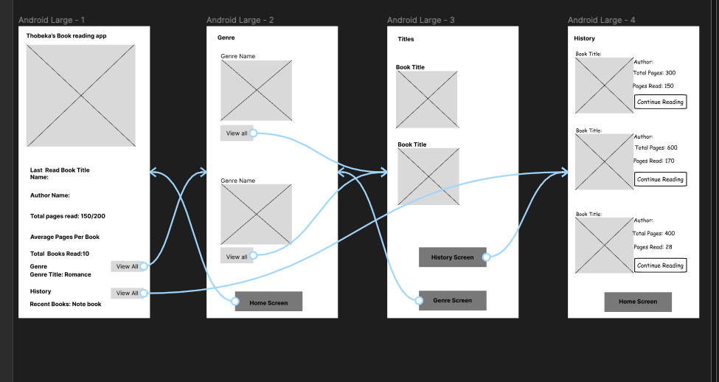

Figure 1

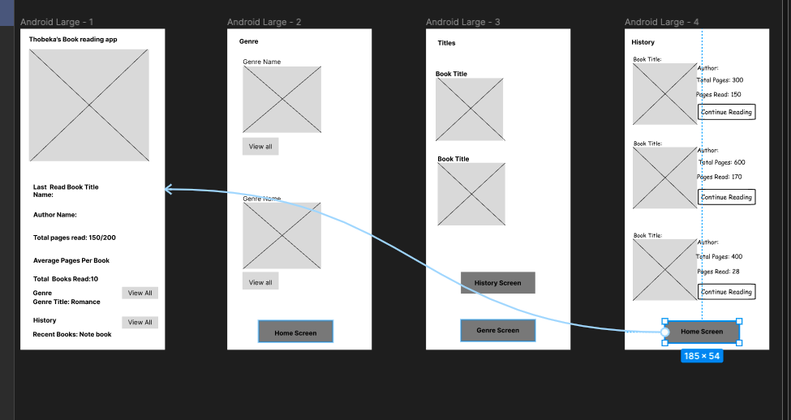

Figure 2

The screenshots above display figma wireframes of how the user would interact between different screens. With the help of the arrows.

However, there will be screenshots of each screen, with more detail down below:

Before displaying the drawing here’s a key:



**KEY:**

This symbol will appear in every screen down below. This symbol represents *logos.* However, the logo will **only** appear in the home screen. The “Genre screen”, “Title screen” and “History screen” symbols will appear as book covers.



Home Screen



This is the home screen of Thobeka’s book reading app. As u can see it displays her last read book, author, total pages read, average pages per book, total books read, genre/title and History.

There are two “View all” Buttons one next to “Genre” and the other at “History”

If the user clicked the “View all” button next to “Genre” then it would take the user to a screen that called “Genre”

**Or**

The user can click onto the “View all” button next to history, where it would take the user to a screen called “History”

(Free figma UX design UI essentials course, 2021)

Genre Screen

Once the user has clicked the “View all” button next to “Genre” from the home screen, then this screen will appear, the Genre screen.

This screen will display a screen with different types of genres such as Mystery, Fantasy, Thriller, Romance, Drama, Crime and Biography.

“Genre Name” will be filled in one of the genre categories mentioned above later on in this POE, for now this is a **planning.**

Below the book cover symbol is a button called “View all”. That will lead the user to a screen called “Title”. For example, let’s say the user has selected the “View all” button under a genre called “Thriller”, once the user has clicked that button, the “Title” screen will appear with all the book titles that are “Thriller novels/books”.

Down below is a “Home Screen” button where the user can click to go back to the home screen and select the “View all” button next to “History” if the user wants to go **directly** to the history screen instead of going through each screen to get there (history screen).

(Free figma UX design UI essentials course, 2021)

Title Screen

Once the user has selected the “View all” button under a certain genre from the “Genre screen”, then this screen will appear next, the title screen. Where title of the books will appear. As mentioned before, if the user has selected a “Thriller” genre then this screen will appear with titles of the book that are thriller.

Down below u see “history screen” and “Genre screen”

The “History screen” button is the last screen that will take the user to if clicked on.

The “Genre screen” button is when the user wants to go back to the “Genre screen” and select a different genre.

(Free figma UX design UI essentials course, 2021)

History Screen

If the user has clicked on “View all” button next to history, in the home screen or has clicked The “History screen” button in the “Title screen”. Then it will take them to this last screen. The “History” screen.

The History screen shows the users history with different books, such as the book title, author, total pages, pages read and “Continue reading” button.

Next to each book, there is a “Continue Reading” button, where the user will continue reading the book where they left off.

Down below is a “Home screen” button that the user can click on to go back to the home screen.

(Free figma UX design UI essentials course, 2021)

# Part 2-Adding Logic

In this part, we are adding logic to the app, so the user can interact with it. In this part, CSS and logic has been added. Button do function, a drop down list for users to choose a genre.

The App still follows the Figma wireframes, only difference is that color&buttons that work(CSS) are added and logic is added such as the Picker function and a function that allow users to enter the following details of a book:

Title

Author

Genre

Number of pages

More detail will be explained in the video.

# Portfolio of Evidence — Polishing and Last Features

## Feedback received from Part 1 and Part 2

Part 1:

There was nothing to improve or add to part one, but to be more engaging when it comes to the videos.

Part 2:

Here are the following feedbacks from part 2

* Build a form to insert different values in one screen
* Selecting genre from list
* The home screen must display last book details
* Home screen should display the total pages and average.

Changes that were implemented from Part 2 feedback:

* The form is inserted and different values are in one screen.
* User can select genre on one screen instead of going to another link.
* The home screen must display last book details (In the POE, the last book details will be displayed in the history screen)

POE/Part 3:

In the beginning, there were four screens, Home, Genre, Title and History.

In the POE, the Title Screen does not exist as it unnecessary screen, however the Home, Genre and History are still available.

Additional elements that have been added to the app:

* A history screen where the last three books read by the user are  displayed
* A genre screen where the total number of books read in each genre is displayed

# References:

*Free figma UX design UI essentials course.* 2021. [Film] Directed by Dan scott. America: s.n.